Miguel Patxot

**Multi Year Stock Data –Homework 2**

Submission Requirements: “A screen shot for each year of your results on the Multi Year Stock Data.”

**2014:**

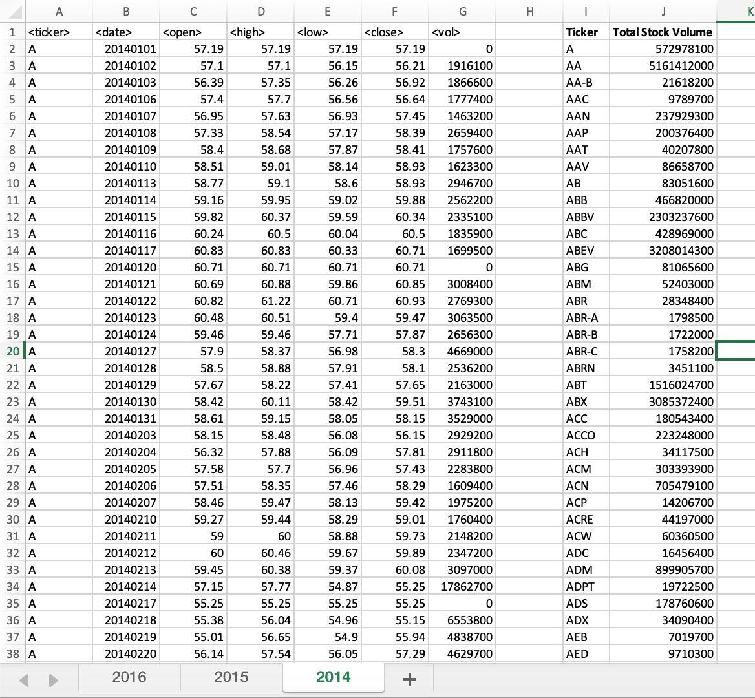

**2015:**

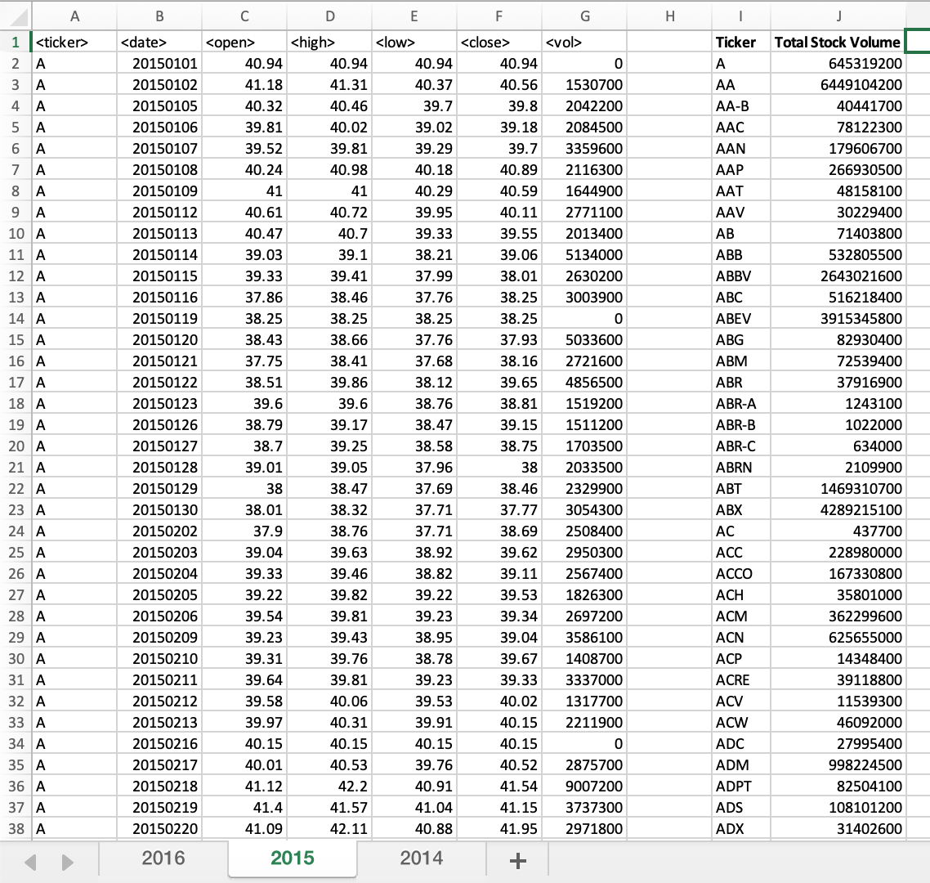

**2016:**

